**Analytic Memo 5**

**Jessica Lewis, 10/8-10/12**

1. **What data did you collect this week?**

Wednesday 10/10

* Discussion #5 - The students were asked to research and share a website, game, or app that can help them use math.
* Used outlined questions to guide their research and support their explanatory skills.
* I completed the **Teacher Observation Form** for each student.

Friday 10/12

* Peer Comments #5 - Comments on peers’ posts
* I completed the **Teacher Observation Form** for each student.
* I completed the **Blog Evaluation Form** for Discussion #5.

1. **Review the qualitative data that you collected this week. List five to ten words (potential codes) that come to mind as a result of this data.**

I did not add any new codes this week. I went ahead into to week 7 and read chapter 5 in Saldana (2016). I attempted to use a second round coding technique called *focused coding.* This method organizes the most prominent codes from the first cycle of coding into 5 main categories. The main 5 categories represent the reoccurring themes that are displayed from the data. These will eventually be developed into the major findings of the study. Each main category has bulleted sub-categories outlining the details that helped to develop the main category or theme. Some of subcategory bulleted notes overlap because motivation, achievement, and self-efficacy are linked to each other. Below is what I came up with. Let me know if it makes sense.

Category 1: Increased motivation (engaged and focused) when:

* Using technology (Chromebooks)
  + “Digital natives” (familiarity)
* They understand the discussion question (discourse)
  + Strong literacy skills
  + Strong self-efficacy
* Collaborating with peers (audience)
  + Learning from each other
  + Support from friends
  + Presented with a challenge
* They value the discussion (intrinsic motivation)
  + Relates to learning
  + Discussion increases their understanding
  + Incorporates preferences and interests

Category 2: Decreased motivation (lack of effort) when:

* They do not understand the discussion prompt (discourse)
  + Prompt is too challenging
  + Low literacy skills
  + Low self-efficacy
* Asked to critically think (discourse)
  + Explaining thoughts
  + Justifying thoughts
  + Analyzing and conceptualizing peer posts
* Reading directions or long texts (discourse)
  + Low literacy skills
  + Critical thinking
* Reading peer posts
  + Seeking instant communication

Category 3: Peer audience increases self-efficacy (confidence in learning) by:

* Multiple perspectives
  + Access to new information
  + Increases understanding
* Clarification from peers
  + Supports confidence in knowledge/abilities
* Increasing awareness to details and writing quality
  + Conscious of spelling
  + Wanting to impress peers

Category 4: Mathematical discourse lays the foundation for blogging success:

* Become off task when they do not understand
* Lack of literacy skills impacts peer discussion
  + Poor writing impacts the readers understanding
  + Poor reading impacts understanding
* Strong literacy skills increase success on blog
  + Explaining & justification skills

Category 5: Peer discussion increases academic achievement

* In explanation skills
  + Displayed on blog posts and unit test
* Peer audience
  + Explain so peers can understand
* Still struggle with justification skills

1. **In a table, share the quantitative data that you collected this week. This data should not be individual according to student – but should be presented in the form of averages or percentages. Write a short explanation (one or two sentences) of what you think this data means in terms of your research question (s).**

**Teacher Observation Form -** The numbers below represent the average in each category for 9 students. The total amount of points for each category is 4.

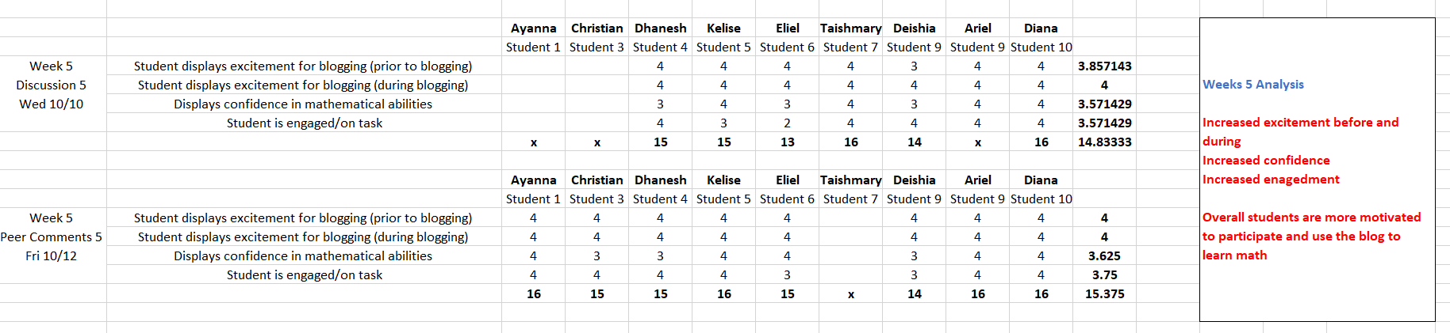

As the study progresses, the students become more and more exciting about the blog each week. They enjoy using the technology during math. Students understand how to access the blog and understand the purpose of writing on a blog. They are displaying more excitement before and during blog use and require less teacher direction each time we have a blog session. This is displayed in their confidence in mathematical abilities and engagement on the task. This instrument is strictly used for observations. Although a student may look confident in their mathematical abilities, this does not directly reflect their mathematical discourse and understanding of the content (this data is displayed in the **Blog Evaluation Rubric**).

**Blog Evaluation Rubric -** The numbers below represent the average in each category for 9 students. The total amount of points for each category is 2.

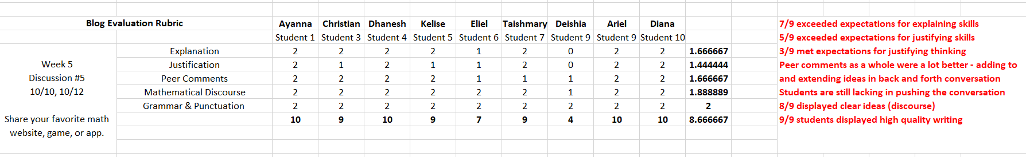

This week the blog evaluation rubric displayed a significant increase in each category. Read the red comments for further detail.

1. **Write at least one paragraph (it could be more if you like) reflecting on your experience of the week in terms of both student performance and your own practice.**

Student performance went exceptionally well this week. The students displayed a break through in their explanation, justification, and discussion skills. This could be the result of having practiced their skills over the last few weeks or because of the discussion content. The students also displayed increased motivation, excitement, and engagement during blog time. Compared to previous discussions, this week’s discussion asked students to review their favorite website, game, or app that helps them learn math. The content was relevant to their learning and incorporated their preferences and interests. Each student’s post was unique and represented their personal thoughts and opinions. I believe this made it easier for them to engage in discussion. They actively added and pushed the conversation in their peer comments. In most student posts I was able to see strong skills in both explaining and justifying.

To support the students’ explanation and justification skills, I provided them with some question prompts to guide their posts. One to the questions directly prompted them to explain while another directly prompted them to justify. This outlined a question and answer approach them enabled them to explain and justify their ideas separately. I don’t think the students even realized they were explaining and justifying.

1. **Write a few sentences (it could be more if you like) outlining the way that this week’s memo is different from last week’s memo.**

This week’s memo is different from last week’s memo in that the students displayed significant gains in explaining, justifying, and discussion skills. It helps me understand the type of content structure needed to enable students’ explanation, justification, and discussion skills.

I am starting to develop themes from the data and codes used. I used *focused coding*  methods to develop my second cycle coding themes.

**Field Notes**

**Week 5 (Wed, 10/10) – Discussion #5**

* Blog about sharing your favorite website, game or app that helps you learn math
* Students were all very excited before and during
* They said it helps them explain their thinking about math
* S: “this is fun!”
* Next Time:
  + Peer comments
  + Open a discussion about how to extend the conversations between peers

**Week 5 (Fri, 10/12) – Peer Comments #5**

* Students were directed to read peer posts and explore the math resource from the comment. They had to respond to at least one peer post
* Students got right to work and knew exactly where to go to access the blog
* Students enjoyed reading and exploring peer comments about games
* Really pushed them during blog time to explain their thoughts – helped push a few students even further
* S: “can I write more that one peer comment”?
* Next Time:
  + Wed: Have students go back and forth to one another in discussion 5
  + Wed: Push back and forth conversation even further
  + Fri: Have them solve a problem that asked them to justify and explain their thinking